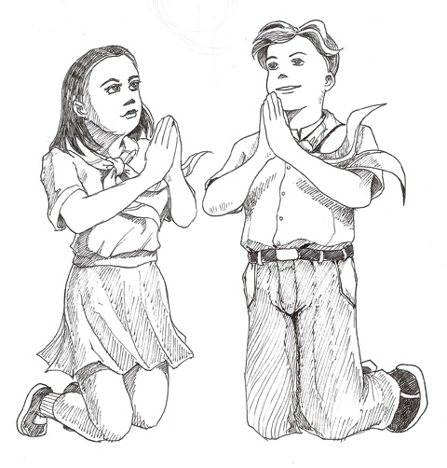
Living the Eucharistic Day
Background:
- What does “living the Eucharistic Day” mean?
_______________________________________________________________________________________________________________________________________________.
- Why do we need to live this day?
_______________________________________________________________________________________________________________________________________________.
- Praying as well as living the Eucharistic day every day helps us become _________________ and closer to ______________.
- This day focuses on the ___________ _____________________, which is the center of our ___________.
- What do the words “Spiritual Bouquet” mean? (Hint: We offer this up to Mary)
______________________________________________________________________.
- What are the five parts of the Spiritual Bouquet? (Vietnamese and English)
  - ______________________________ _________________________________
  - ______________________________ _________________________________
  - ______________________________ _________________________________
  - ______________________________ _________________________________
  - ______________________________ _________________________________
- What do we do with the Spiritual Bouquet?
_______________________________________________________________________________________________________________________________________________________________________________________________________________________.
Contents:
- What are the three parts of the Eucharistic Day?
  - The Morning Prayers
  - _____________________________________________________
  - The ________________ Prayers

